Submission by:

Tikhon Riazantsev

Agastya Heryudhanto

Exercise sheet 5

TASK 1: DUALITY

1. **Show that the dual of the primal is the primal again.**

The transformation takes a Linear Program of the form:

$$\max\left(c^{T}x\right)subject to Ax≤b and x≥0$$

and gives the dual Linear Program of the form:

$$\min\left(b^{T}y\right)subject to A^{T}y≥c and y≥0$$

To get the dual to the form where we can subject it to the dualization again let us multiply everything by the factor of -1 so we get:

$$\max\left(-b^{T}y\right)subject to-A^{T}y≤-c and y≥0$$

Let us now consider this the primal and get the second order dual from it:

$$\min\left({-c}^{T}x\right)subject to-Ax≥-b and x≥0$$

And now finally multiply it by -1 again:

$$\max\left(c^{T}x\right)subject to Ax≤b and x≥0$$

As we can see, the dual of the dual is indeed the primal.

1. **Show that the Weak Duality Theorem follows from the Strong Duality Theorem.**

Weak duality theorem states that if x is a feasible solution to the primal and y is a feasible solution to the dual, then:

$$b^{T}y≥c^{T}x$$

Strong duality theorem states that if x* is an optimal solution to the primal, then there is an optimal solution y* to the dual with:

$$b^{T}y^{*}=c^{T}x^{*}$$

If there exist both the feasible solutions to the dual and the primal than (without proof) there exist optimal solutions to both.

The optimal solution to the primal is made by maximizing $c^{T}x$, which means:

$$c^{T}x^{*}≥c^{T}x$$

The optimal solution to the dual is made by minimizing $b^{T}y$, which means:

$$b^{T}y^{*}≤b^{T}y$$

By now using the strong duality theorem to both previous inequalities we can see that the weak duality theorem indeed follows from the strong duality theorem:

$$b^{T}y≥b^{T}y^{*}=c^{T}x^{*}≥c^{T}x$$

$$b^{T}y≥c^{T}x$$

1. ***Considering the Linear Program given below answer the following questions:***

$$maximize 3x_{1}+x_{2}$$

Subject to:

$$2x_{1}+x_{2}≤7$$

$$x_{1}≥1$$

$$x_{1}≤3$$

$$x_{1}-x_{2}≥-1$$

Where:

$$x_{1}≥0$$

$$x_{2}≥0$$

1. **Draw the graphical solution of the Linear Program and mark the solution polyhedron as well as all possible solutions.**

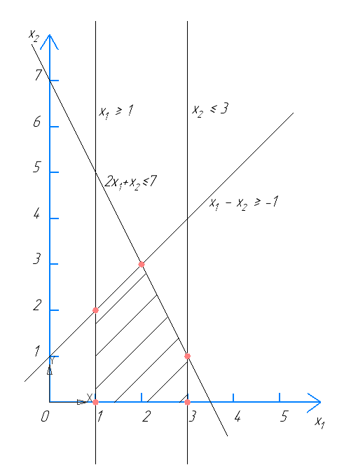

1. **Identify the optimal solution x* as well as the so-called carrier constraints (see Equilibrium Theorem).**

In Linear programming the solution is always on the vertex of the solution polyhedron. Let us check all of the solutions and see which one gives us the biggest target function:

|  |  |  |
| --- | --- | --- |
| x1 | x2 | 3*x1+x2 |
| 1 | 0 | 3 |
| 1 | 2 | 5 |
| 2 | 3 | 9 |
| 3 | 1 | 10 |
| 3 | 0 | 9 |

So the optimal solution is:

$$x_{1}=3 ; x_{2}=1$$

With the carrier constraints:

$$2x_{1}+x_{2}≤7$$

$$x_{2}≤3$$

1. **Give the dual representation of the primal problem.**

Let us first find the matrix A and vectors b and c for the canonical (?) representation of the primal:

$$A=\left(\begin{matrix}2 & 1 \\ -1 & 0 \\ 1 & 0 \\ -1 & 1\end{matrix}\right), b=\left(\begin{matrix}7 \\ -1 \\ 3 \\ 1\end{matrix}\right), c=\left(\begin{matrix}3 \\ 1\end{matrix}\right)$$

From which we can now easily derive the systems of equations for the dual representation of the problem:

$$minimize 7y_{1}-y_{2}+{3y}_{3}+y_{4}$$

Subject to:

$$y_{1}+y_{4}≥1$$

$$2y_{1}-y_{2}+y_{3}-y_{4}≥3$$

Where:

$$y_{1}≥0, y_{2}≥0, y_{3}≥0, y_{4}≥0$$

1. With the help of the Equilibrium Theorem and the dual, explicitly determine the optimal solution y* of the dual problem.

As the equilibrium theorem states, we may rewrite the dual problem using only the carrier constraints from the primal with no impact on the optimal solution:

$$minimize 7y_{1}+3y_{3}$$

Subject to:

$$y_{1}≥1$$

$$2y_{1}+y_{3}≥3$$

Where:

$$y_{1}≥0, y_{2}=0, y_{3}≥0, y_{4}=0$$

From which it is quite obvious (first minimizing y1 and getting the value of y3 as the minimal from the second constraint) to get to the final solution:

$$y_{1}^{*}=1, y_{3}^{*}=1$$

Or $y^{*T}=\left(\begin{matrix}1 & 0 & 1 & 0\end{matrix}\right)$

If we now perform the strong duality theorem, we will see that it applies to out dual and primal solutions which means that we have found the optimal solution correctly.

$$b^{T}y^{*}=7*1+3*1=10$$

$$c^{T}x^{*}=3*3+1*1=10$$

$$b^{T}y^{*}=c^{T}x^{*}$$